**S3 Daily Task Assignment**

1. **Create an S3 bucket and upload some objects to S3.**

* Go to AWS Management Console.
* Search for **S3** service and open it.
* Click on **“Create bucket”**.
* Give your bucket a **unique name** (bucket names must be globally unique).
* Choose a region
* Keep default settings for now and click **“Create bucket”**.

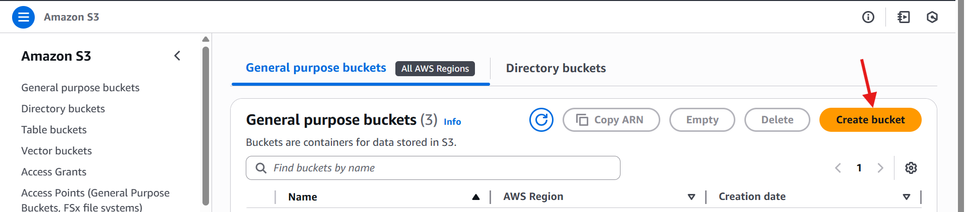

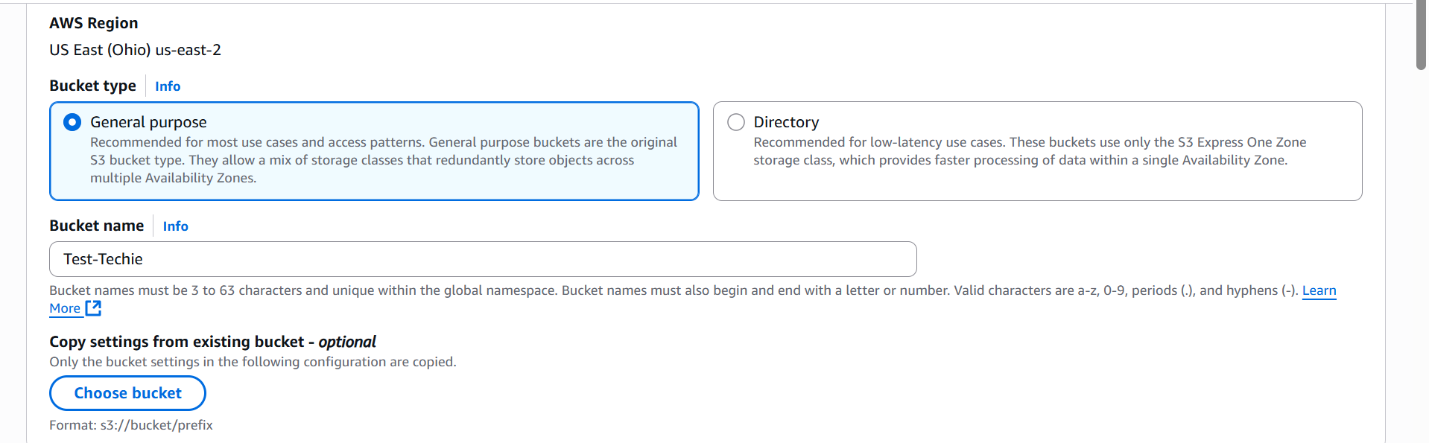

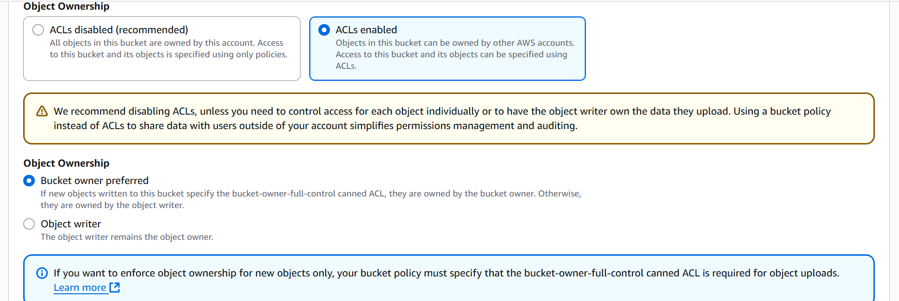

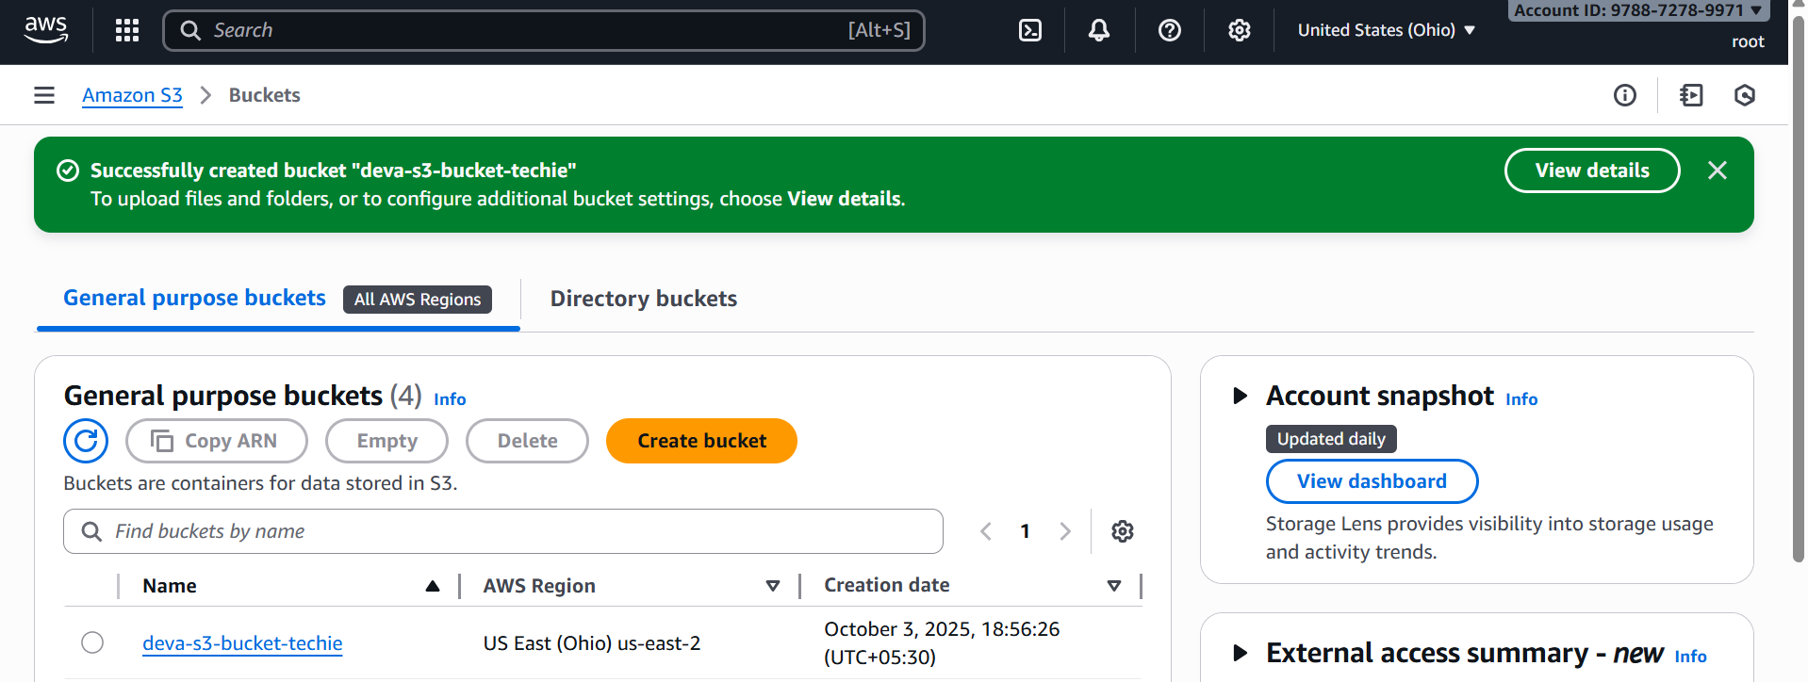

* Open the bucket you just created.
* Click **“Upload”**.
* Add files from your computer (for example: images, text files, PDFs).
* You can also drag and drop multiple files.
* Click **“Upload”** to finish.

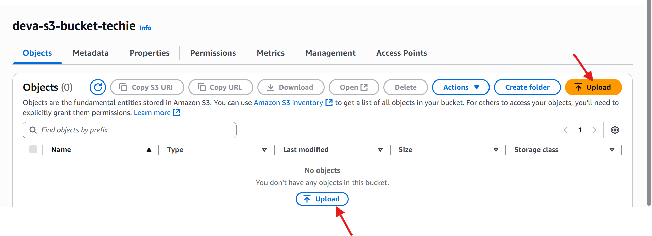

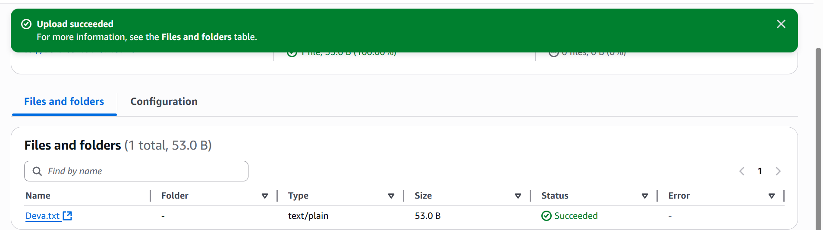

* After upload is complete, you will see the list of files inside your bucket.
* Each file has an **Object URL**.
* Copy the URL and open it in a browser.
* By default, objects are private.
* Select a file → Go to **object actions** → click on **make public using ACL**.
* Now anyone with the **Object URL** can access it.

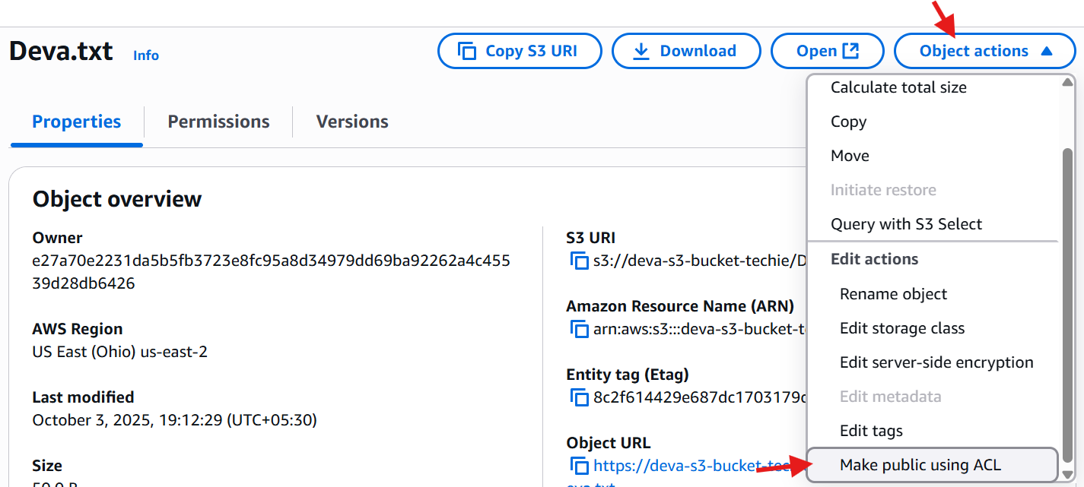

* After making public
* Copy the URL and open it in a browser.

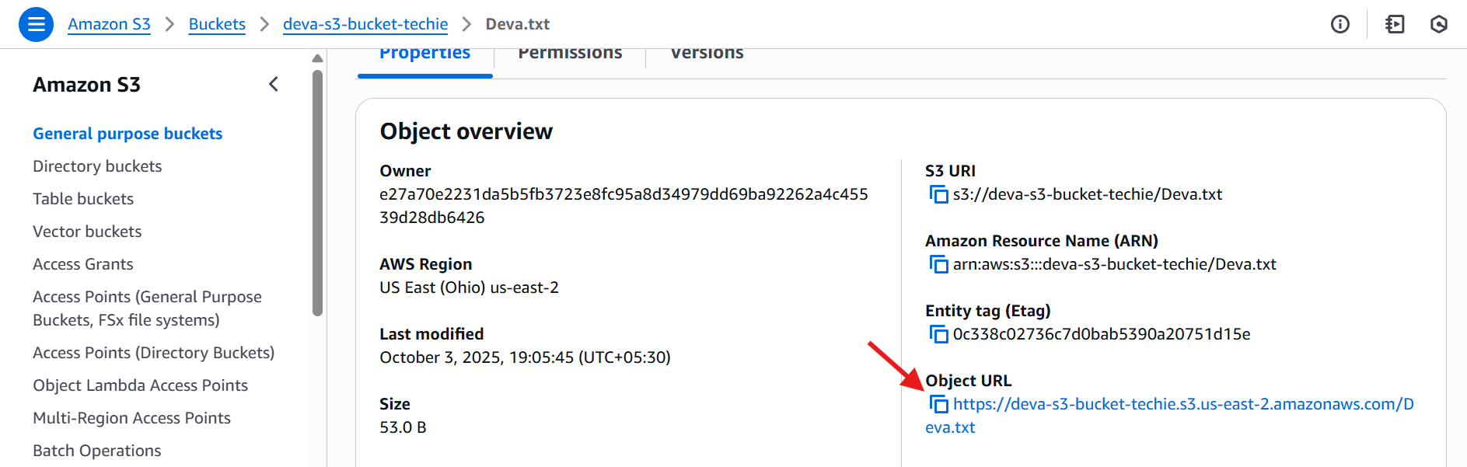

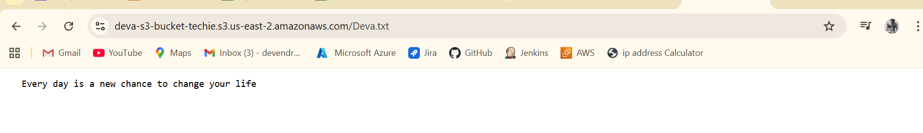

1. **Deploy a static website in the S3 bucket.**

* Go to AWS S3 service.
* Click **Create bucket**.
* Bucket name must be unique
* Choose the region
* Keep default options and create

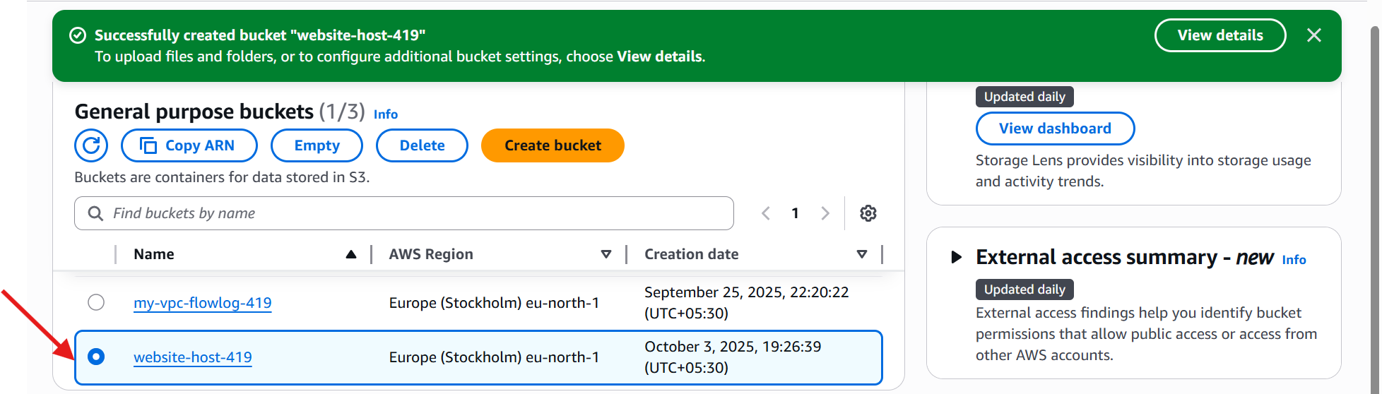

* Prepare your static website files (for example: index.html, error.html)
* Open your bucket → click **Upload**.
* Add all the files and click **Upload**.

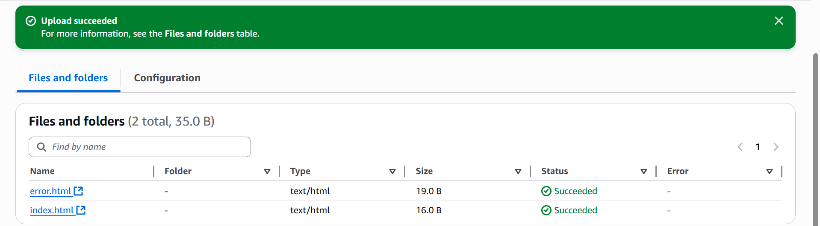

* Open the bucket → go to **Properties** tab.
* Scroll down to **Static website hosting**.
* Enable it → Choose **Host a static website**.
* Enter index.html as **Index document** (and optionally error.html).
* Save changes.

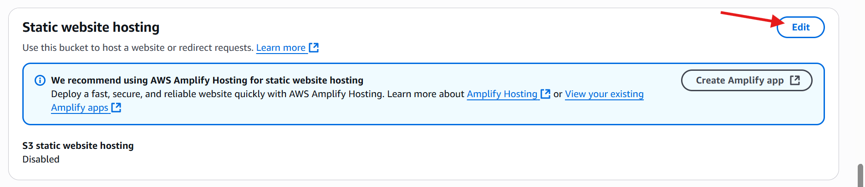

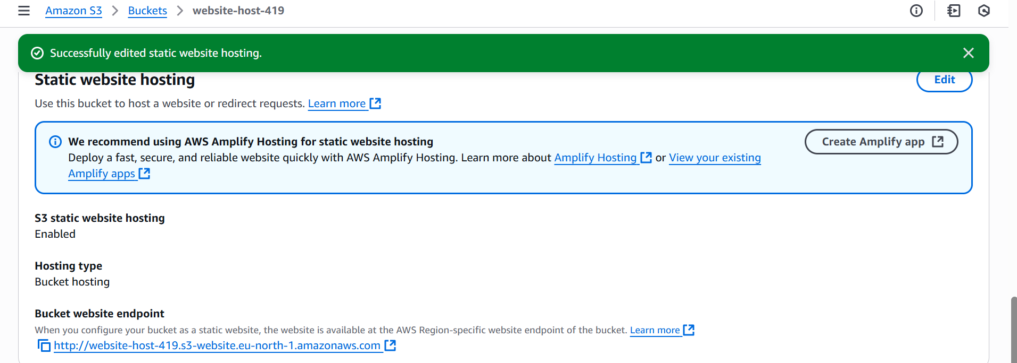

* Copy the URL and paste it in a browser and check.

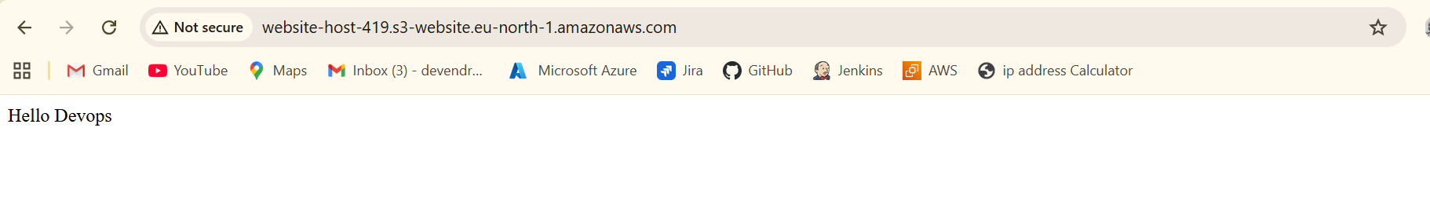

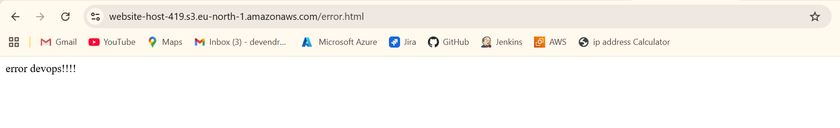

1. **Enable cross-region replication on S3 buckets.**

* You need to create two buckets
* Source bucket
* Destination bucket
* Buckets must be in different regions
* Source**: ohio**
* Destination **: Europe**
* **Versioning must be enabled** on both buckets.

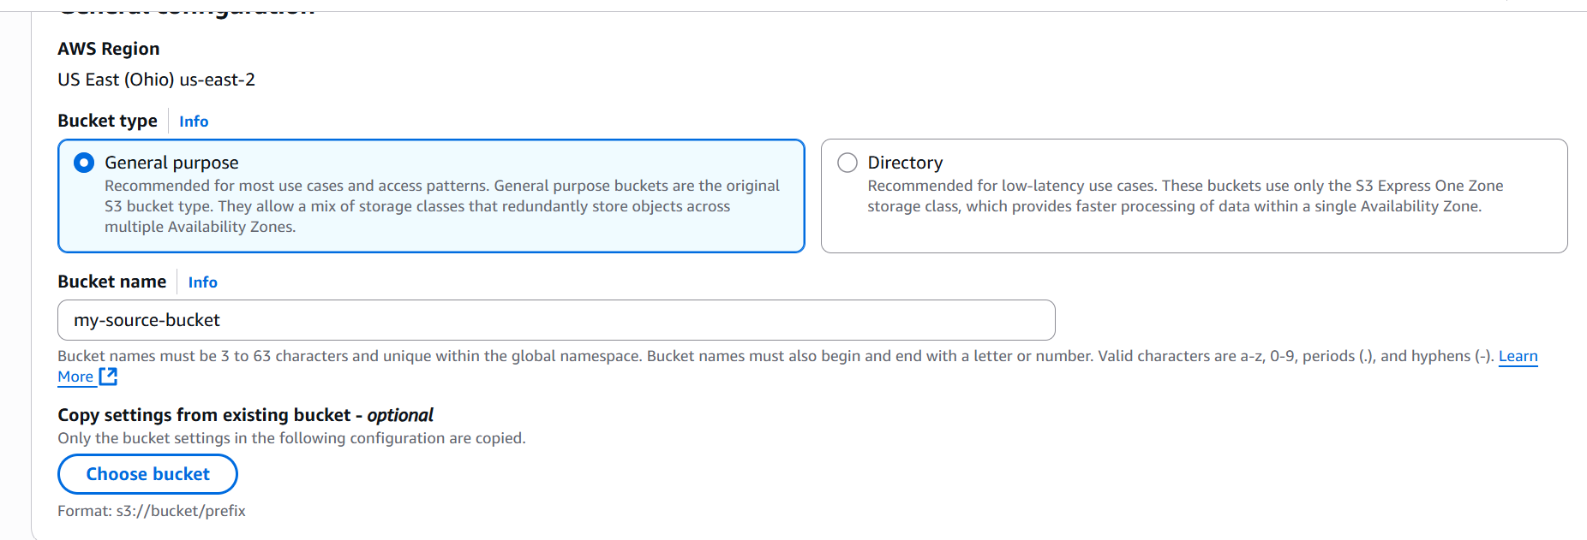

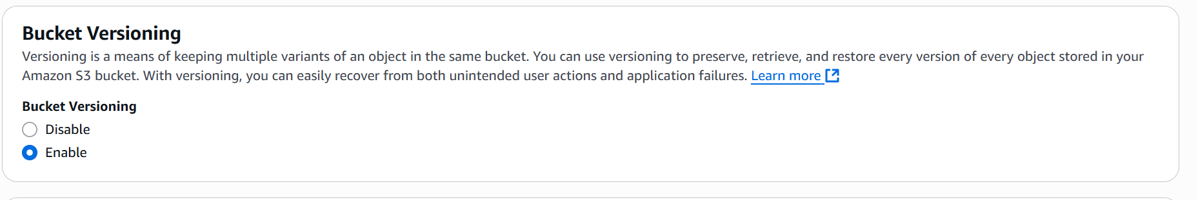

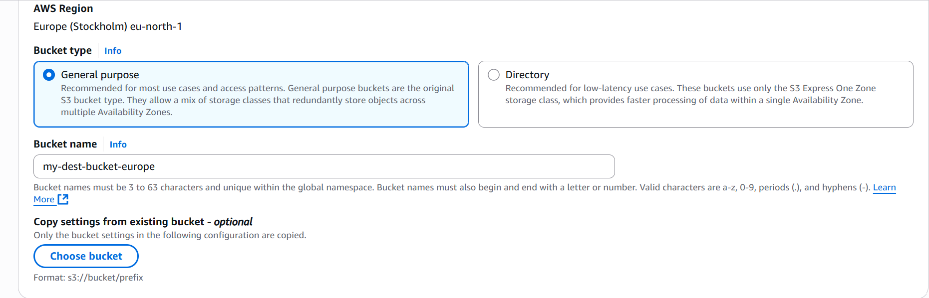

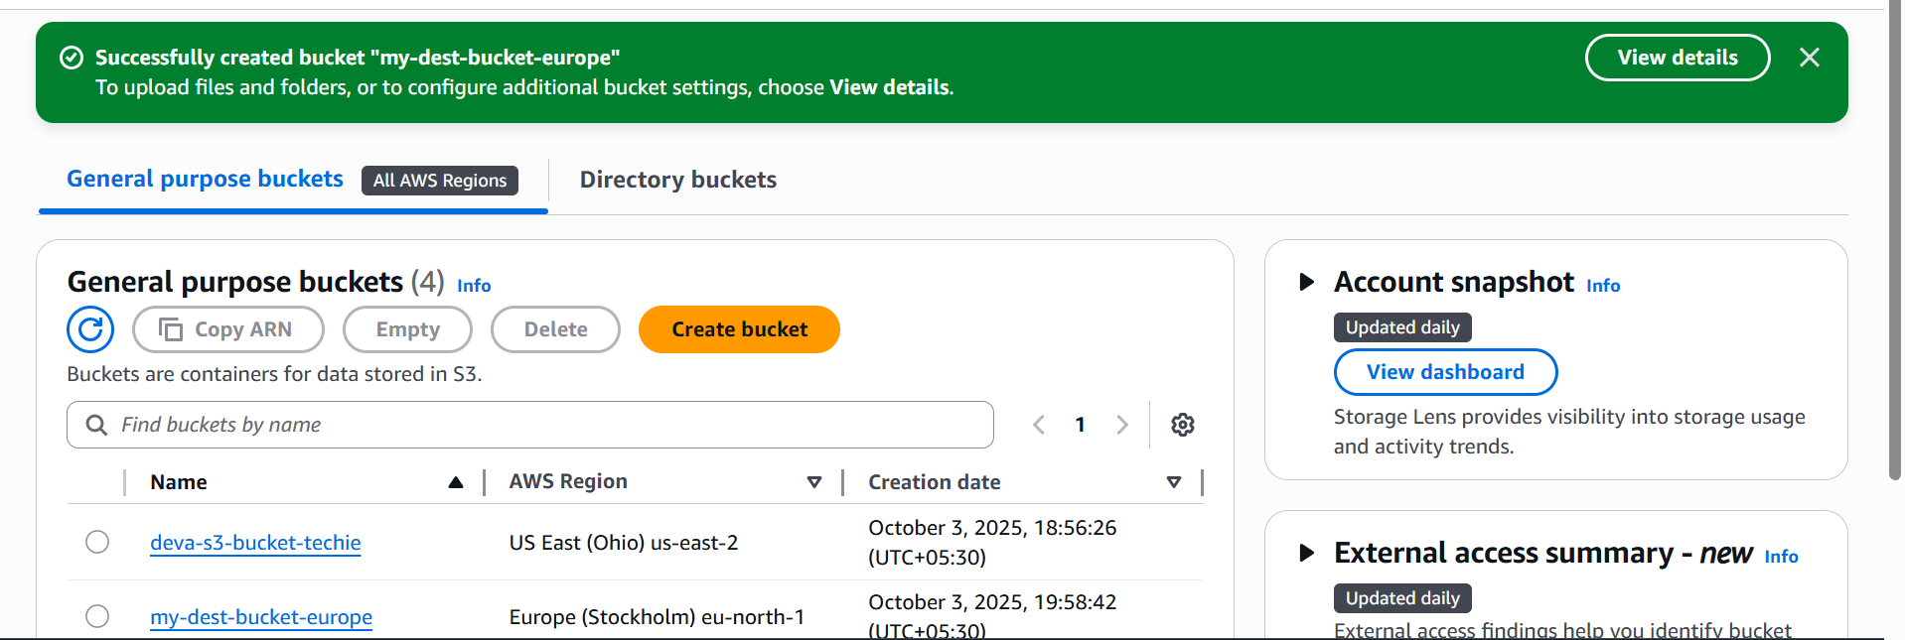

* When you enable replication, S3 automatically creates an **IAM role** that allows replication.
* Or you can choose an existing IAM role with s3: Replicate permissions.
* Open the **Source bucket**.
* Go to **Management** tab → **Replication rules** → **Create replication rule**.
* Give the rule a name
* Choose **Apply to all objects**
* Select the **Destination bucket** in another region.
* Choose/create an IAM role for replication.
* Save the rule.

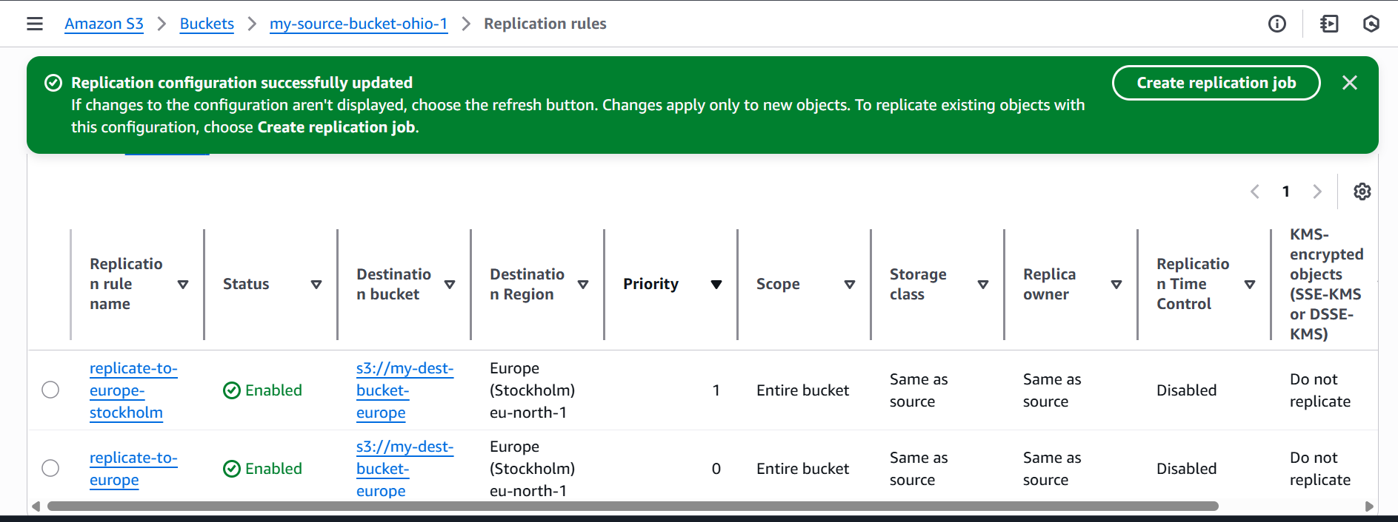

* Upload a new file to the **Source bucket**.
* Check the **Destination bucket** in the other region

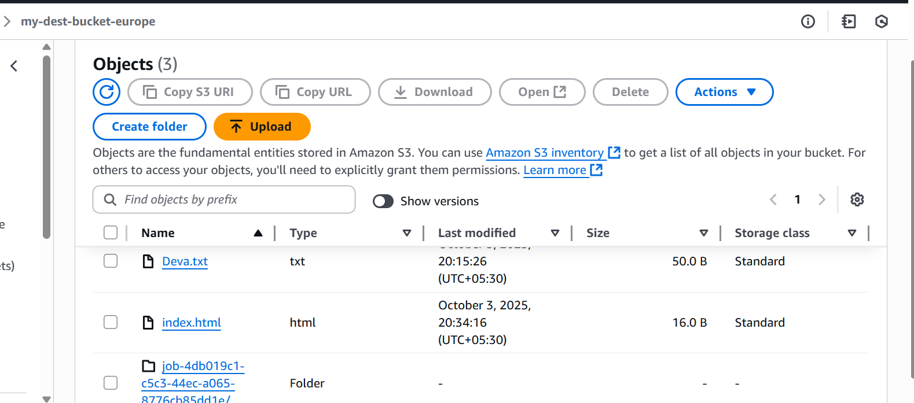

1. **Configure a bucket policy so only the Admin user can see the objects of the S3 bucket.**
2. **Set up lifecycle policies to automatically transition or delete objects based on specific criteria**

* Open **AWS Management Console** → Go to **S3 service**.
* Select the **bucket** where you want to apply the lifecycle policy

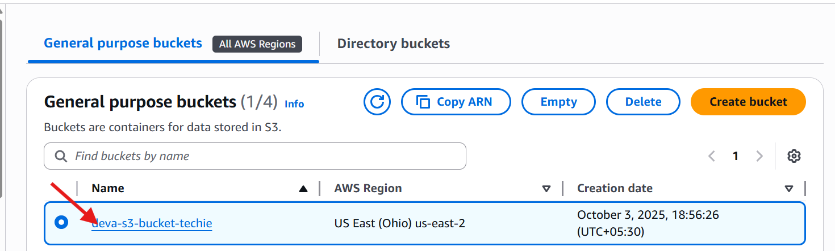

* **Navigate to Management Tab**
* Inside the bucket → Click **Management** tabs.
* Scroll down to **Lifecycle rules** section

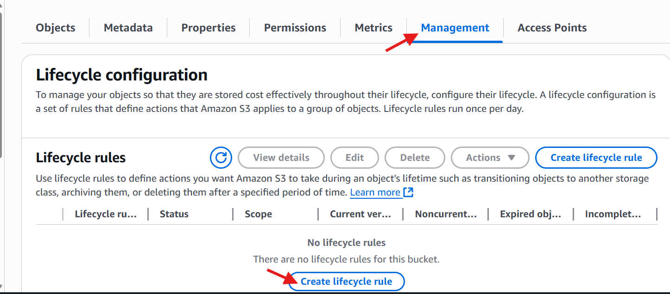

* Click **Create lifecycle rule**.
* Enter a **Rule name** **(Archive-transition-logs).**
* You can apply to **all objects** in the bucket

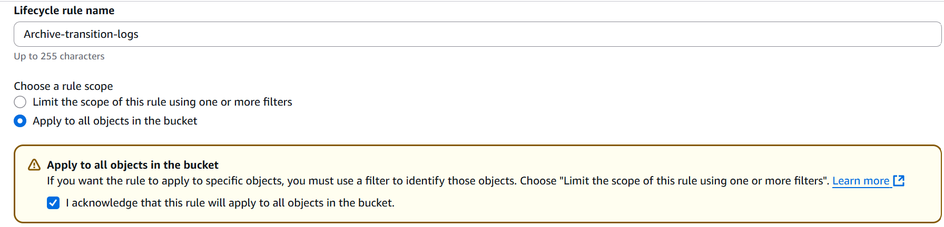

* **Lifecycle rule actions**: select **Transition current versions of objects between storage classes**

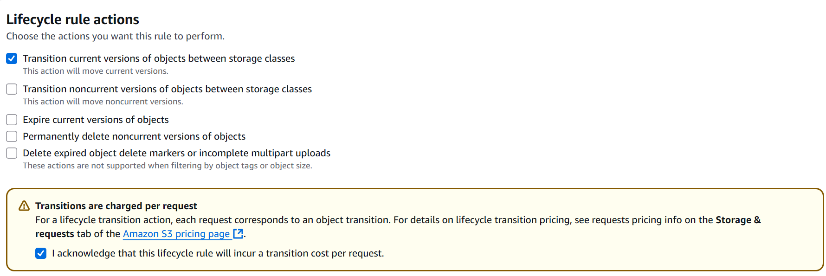

* Move to **S3 Standard-IA and** select days after object rejection after **30 days**.
* Move to **Glacier Deep Archive** after **90 days**.
* Click **Create rule**.

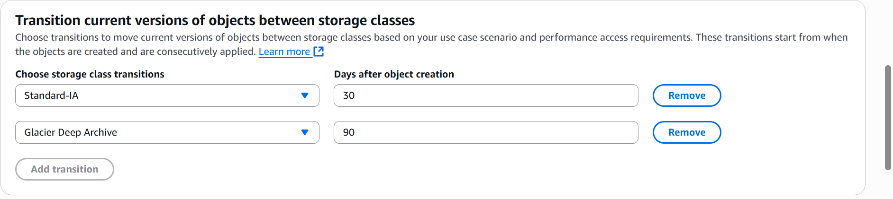

* Created a lifecycle policy to automatically transition or delete objects based on specific criteria.

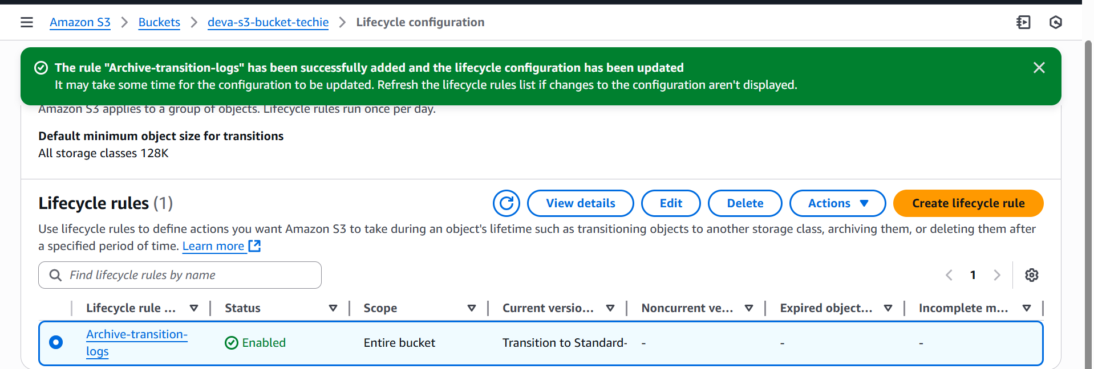

1. **Push some objects to S3 using the AWS CLI.**

* Check the CLI installed or not
* **aws --version** – it shows the version

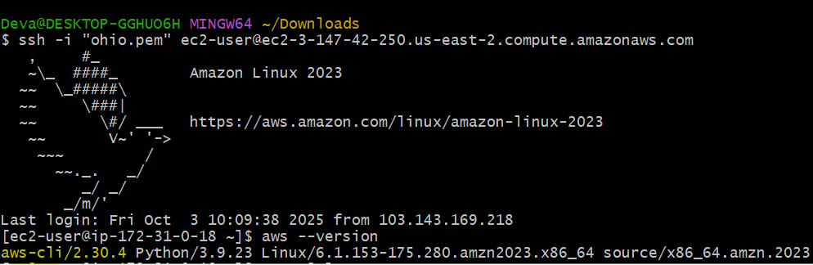

* Give **aws configure**
* Give **AWS Access Key ID**
* Give **AWS Secret Access Key**
* **Region name** (us-east-2)
* **Output format** (json)

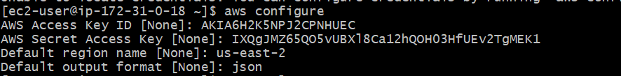

* Here I created one file (**file.txt)**



* And push the file to your bucket (**deva-demo-bucket-01)**
* Check in s3 bucket



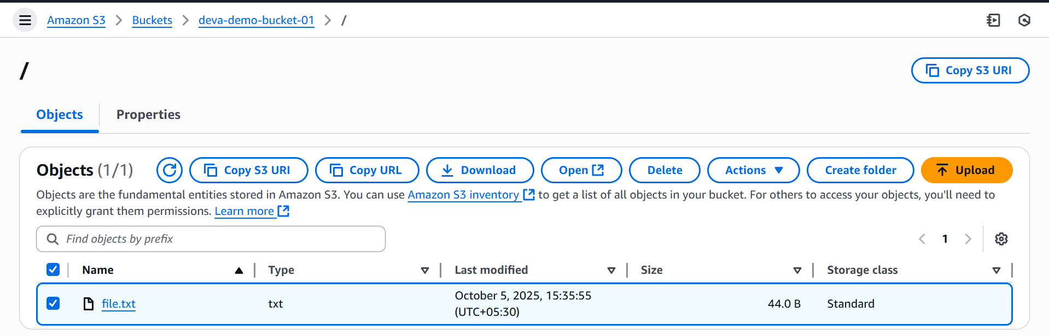

1. **Write a Bash script to create an S3 bucket.**

* Open your gitbash terminal
* Create one file (**vi create-s3-bucket**)
* And paste the below script
* Save and exit **(esc+:wq!)**

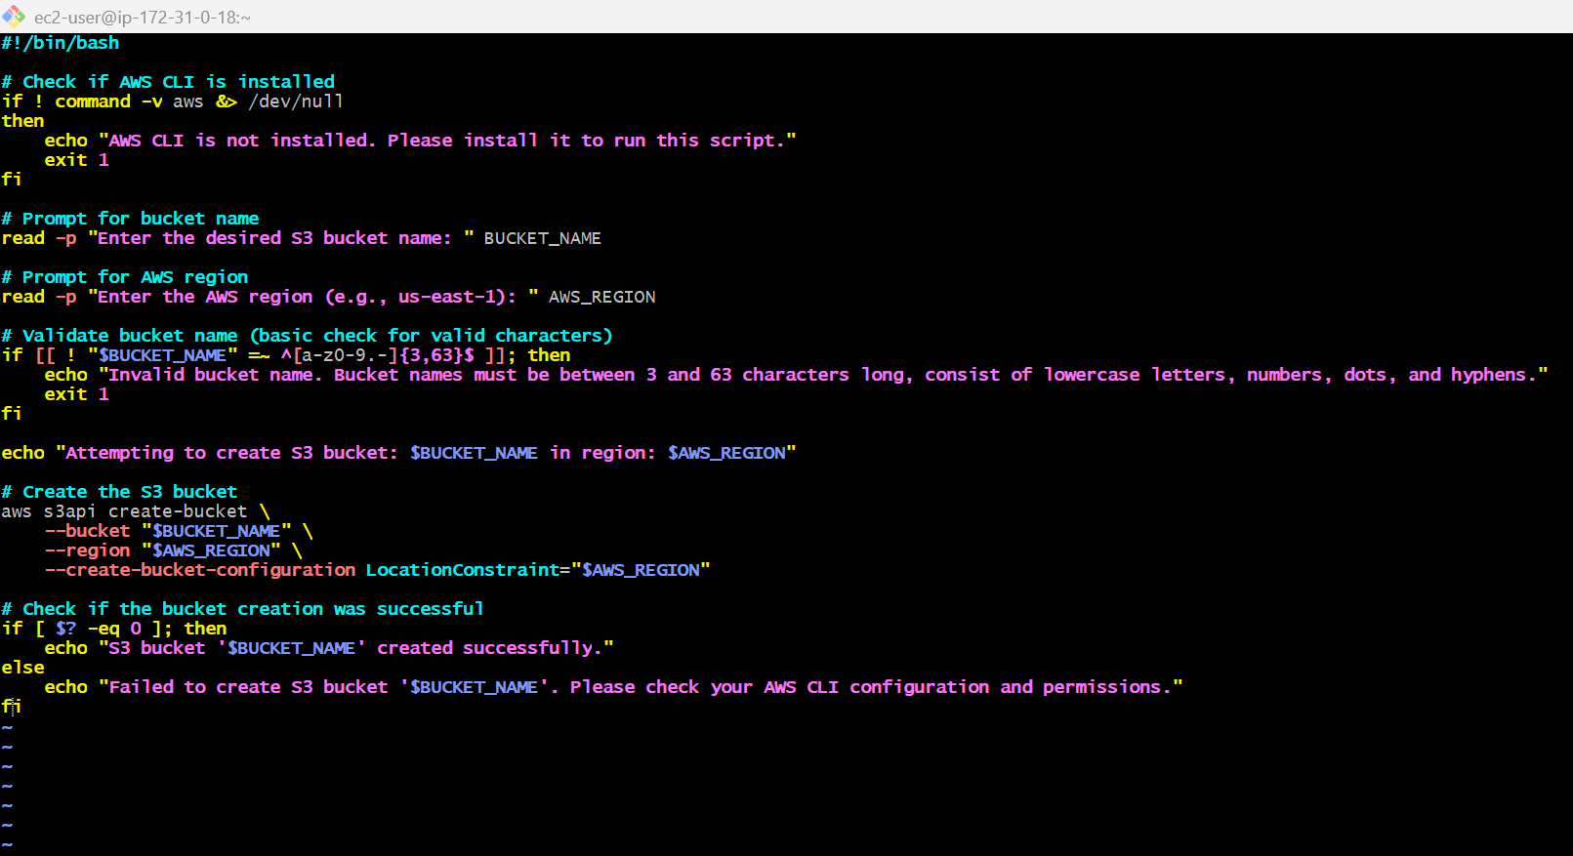

* Provide permissions to that file **(chmod +x file name)**
* And execute **(./filename)**
* Give **bucket name**
* **Region**

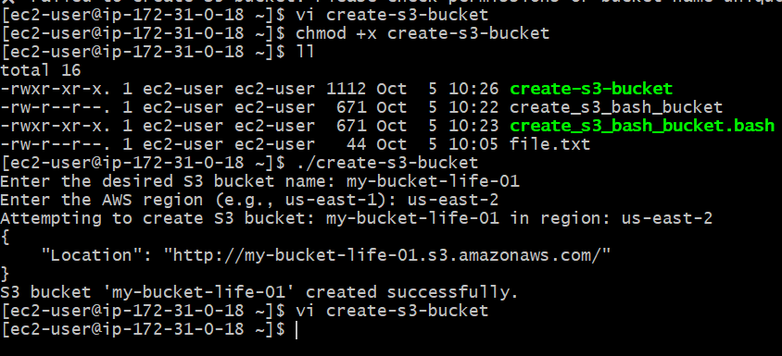

* To show the liost of buckets- **aws s3 ls**

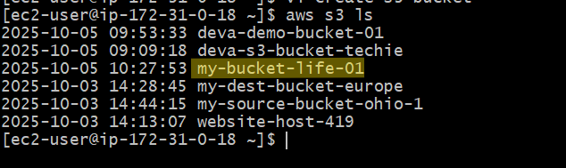

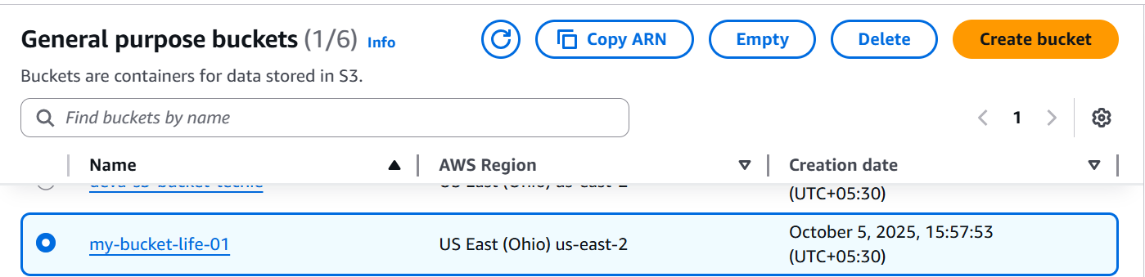

1. **Upload a 1 GB file to S3 using the CLI.**

* Go to downloads and open gitbash there.
* Then using $ dd if=/dev/zero of=bigfile1GB.txt bs=1M count=1024
* This command is create a one dummy file for 1 GB capacity.
* Then check your bucket list aws s3 ls.

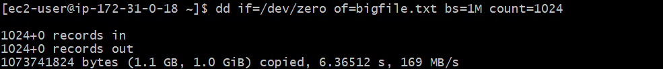

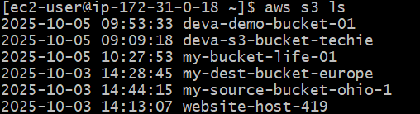

* Upload the file to your s3 bucket.



* Verify and upload



